**Task 10: Test**

Application of Newtons Laws

Name: ­­_______________  
Teacher: ______________

Mark: ­­­­___/52  
Comment: __________________ ____________________________________________________

**Assessment type:** Test

**Conditions**

1 hour, test conditions

**Task weighting**

5% of the school mark for this pair of units

**Part One: Multiple Choice**

1. If two forces are pulling on an object with 4 Newtons each to the right, and one force is pulling on an object with 4 Newtons to the left. What is the net force?
2. 0 N
3. 4 N right
4. 4 N left
5. 8 N right
6. Which statement best describes a soccer ball slowing down on a level ground?

A. A positive acceleration is acting on the ball

B. No net force is acting on the ball

C. The ball is experiencing a net force acting upwards on the ball

D. The force of friction is changing the ball’s speed

1. Which of the following can be best explained by Newton’s second law?

A. A bicycle will slow down on a level road when the rider stops pedalling

B. A passenger without a seatbelt will be thrown forward when the car brakes

C. The acceleration of a rocket is related to the mass of the rocket

D. A moving toy car will bounce backwards upon colliding with a stationary train

1. What is the force of gravity acting on an object called?

A. Weight

B. Mass

C. Reaction force

D. Momentum

1. If a ball is rolling forward, then the force of friction is acting in which direction:
2. Forward
3. Backward
4. Upward
5. Downward
6. What is Newton’s 3rd law:
7. Law of Gravity
8. Law of action-reaction
9. Law of force and acceleration
10. Law of inertia
11. Which of Newton’s laws is best represented by a boy trying to see how far he can kick a soccer ball, a tennis ball, and a bowling ball?
12. Newton’s First Law
13. Newton’s Second Law
14. Newton’s Third Law
15. None
16. A spacecraft is drifting at a constant speed of 500m/s. If a 20N Force is applied to the front of the craft and a 20N force is applied to the back of the craft, what will be the result?
17. The spacecraft will stop with the balanced forces
18. The spacecraft will continue at the same speed with the balanced forces
19. The spacecraft will increase its speed forward
20. The spacecraft will decrease its speed forward
21. What is a difference between an object's speed and velocity?
22. Speed includes direction as well as the rate of travel.
23. Velocity includes time during which travel occurred.
24. Velocity includes the direction of travel whereas speed does not.
25. There is no difference.
26. Which of the following statements correctly states Newton's first law of motion?
27. Every object retains its state of rest or its state of accelerated straight-line motion unless acted upon by an unbalanced force.
28. Every object retains its state of rest or its state of uniform straight-line motion unless acted upon by a balanced force.
29. Every object retains its state of rest or its state of uniform straight-line motion unless acted upon by an unbalanced force.
30. None of the above is correct.
31. The acceleration of a car moving at a **constant** speed of 30 ms-1 is
32. 30 m.
33. 30 ms-1
34. 15 ms-2
35. 0 ms-2
36. The term inertia means which of the following? The tendency of an object to
37. Maintain its mass.
38. Remain in motion only.
39. Remain in rest or motion.
40. Stop the motion of other objects.
41. According to Newton's second law of motion, acceleration is proportional to force. That means a larger force
42. Produces a smaller acceleration.
43. Doesn't affect acceleration.
44. Produces a smaller mass.
45. Produces a larger acceleration
46. You are standing in a moving bus, facing forward, and you suddenly fall forward. You can tell from this that the bus's
47. Velocity decreased.
48. Velocity increased.
49. Right.
50. Speed remained the same, but it's turning left.
51. In order for a moving object to slow down:
52. Any force acting on the object would have to be removed.
53. A frictional force is needed as it is the only one which will achieve this.
54. Some net force has to be applied to the object in the opposite direction to the way it is moving.
55. The force due to air resistance has to be increased.
56. Which of the following forces does NOT act on a car travelling at a constant speed
57. Friction
58. Air resistance
59. Gravity
60. Inertia
61. A plane fires hot air out of its back engines as it flies. What is the reaction force?
62. Thrust
63. Lift
64. Gravity
65. Friction
66. Which of the following statements correctly describes mass
67. A measure of how much force is required to move an object
68. Where atoms go to pray
69. The amount of matter within an object
70. How quickly an object alters speed
71. Which statement correctly describes displacement?
72. The total distance travelled
73. The straight-line distance between the start and end point
74. The speed of a vehicle
75. The velocity of a vehicle
76. What force is required to accelerate 20kg ball to the right at 10ms-2?
77. 200N Left
78. 200N Right
79. 2N Left
80. 2N Right

**Part Two: Short Answer**

1. Find the net force applied in each of the following force diagrams. Do not forget to include the direction.
2. 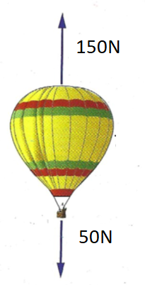

1. 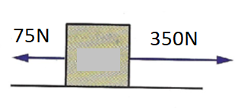

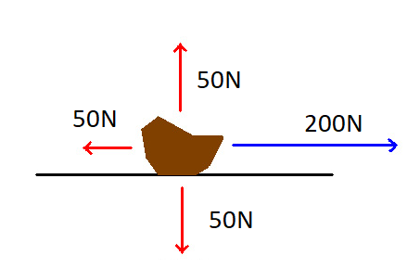

2. 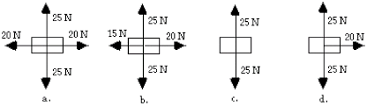

(4 marks)

22. Cars have many safety features designed to protect the driver and its passengers.

a) Explain why a seatbelt is required in a car.

_______________________________________________________________________________________________________________________________________________________________________________________(1 mark)

b) Which of Newton’s laws relate to this scenario? State the definition of this law.

__________________________________________________________________________________________________________________________________________________________________________________________________________________________________________________________________________________________________________________________________________________________________________________________________________________________________________________(3 marks)

c) Explain the importance of the seatbelt using Newton’s law to explain. Use your answers from part a and b to assist you.

____________________________________________________________________________________________________________________________________________________________________________________________________________________________________________________________________________________________________________________(2 marks)

1. Choose one of Newton’s Laws to explain the following images (there is more than one correct answer).

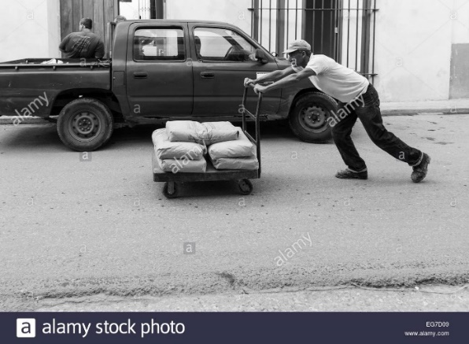a)

_____________________________

_____________________________

_____________________________

_____________________________

_____________________________

_____________________________

_____________________________

_____________________________

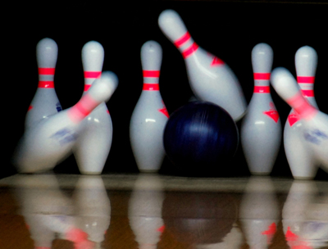

b)

_____________________________

_____________________________

_____________________________

_____________________________

_____________________________

_____________________________

_____________________________

(4 marks)

1. a) A force of 30N accelerates an object by 15ms-2. What is this object’s mass?

(1 mark)

b) A force of 40N to the left is applied to a toy car that has a mass of 750g. What is its acceleration (including a direction)?

(3 marks)

**Part Three: Comprehension**

Imagine that a car is travelling on a straight road. The driver sees a problem on the road ahead and so brakes suddenly to stop. The **stopping distance** is the distance that the car travels from the moment that the brakes are applied to the moment that the car stops.

If the car is initially travelling at ms-1, then the stopping distance $d$ m travelled by the car is given by:

$$d=\frac{u^{2}}{20}$$

For example, if the car was initially travelling at 10ms-1 before the brakes were applied the stopping distance would be:

$$d=\frac{u^{2}}{20}$$

$$d=\frac{{(10)}^{2}}{20}$$

$$d=\frac{100}{20}$$

$d=5 m$ (5 metres)

ms-1

1. Use the formula above to calculate the stopping distance for the following initial speeds, the first one is done for you:

|  |  |
| --- | --- |
| **Initial Speed** (ms-1) | **Stopping Distance** 𝑑(m) |
| 10 | 5 |
| 20 |  |
| 30 |  |
| 40 |  |
| 50 |  |
| 60 |  |
| 70 |  |

(3 marks)

1. Use the table from part a to graph the relationship between initial speed and stopping distance.

(5 marks)

1. Use the graph to predict how far you would travel before you come to a stop travelling at 35ms-1. Show your working on your graph.

_________________________________________________________(1 mark)

1. Use the graph to predict how fast you would be travelling if it took you 150m to stop. Show your working on your graph.

_________________________________________________________(1 mark)

1. What external force helps stop the car when you apply the brake?

_________________________________________________________(1 mark)

1. Using your graph, explain why speed limits are imposed in school zones.

_____________________________________________________________________________________________________________________________________________________________________________________________________________________________________________________(3 marks)